Nicholas Skinner

CS453

Spring 2019

**Project #5: Vector Cloud with Range Sliders**

**Assignment Images:**

Below are a series of images that illustrate the range culling sliders of my submission for the vector cloud assignment. I tried to display both the functionality of the curl slider as well as the speed slider.

**Base -** I tried to display the arrow scaling and the ‘container cube’ in this section as well.

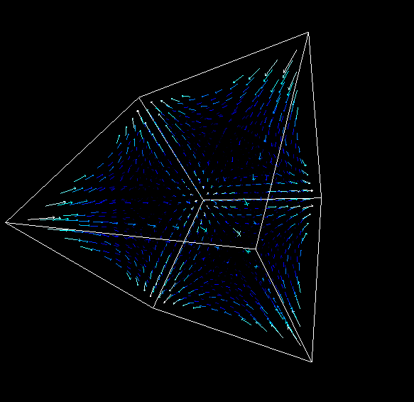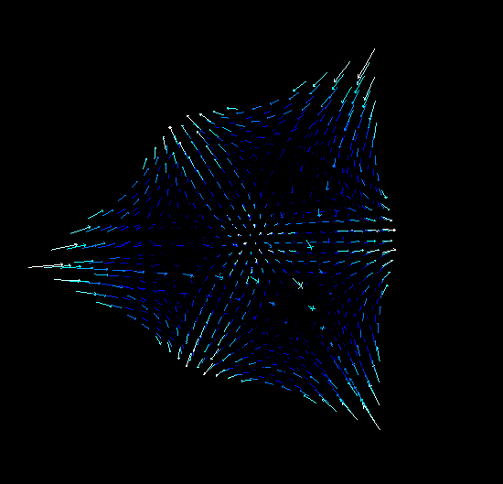

**Curl Slider**

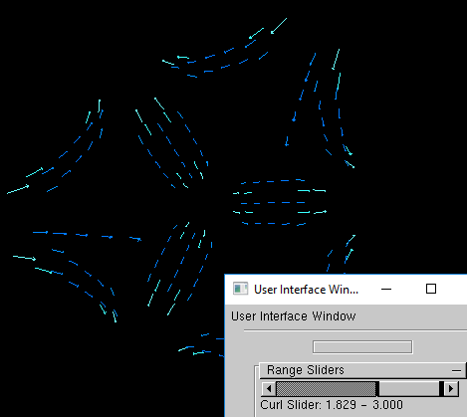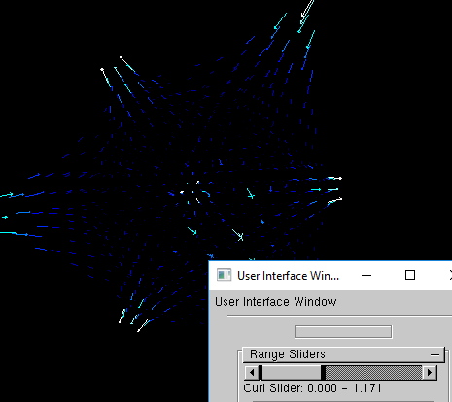

**Speed Slider**

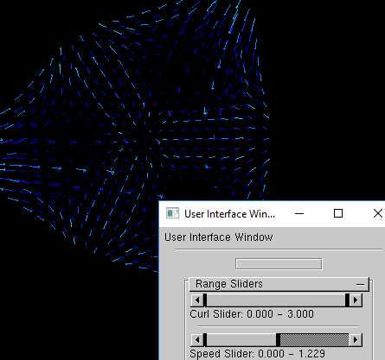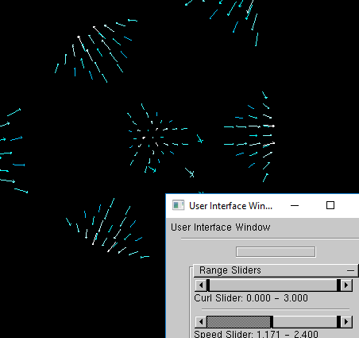

**Reflection**

Overall, this assignment wasn’t too difficult to implement, the hardest part I encountered was implementing the curl function into my vector, after that, it was deciding on a color scheme for the end project, I ended up selecting different shades of blue to determine a slow vs faster display, but looking at it now, maybe I could have made the color transition a bit more severe to draw a more distinct line between slower and faster speeds.

Video - <https://media.oregonstate.edu/media/0_byau5kcr>